Application Deployment Steps

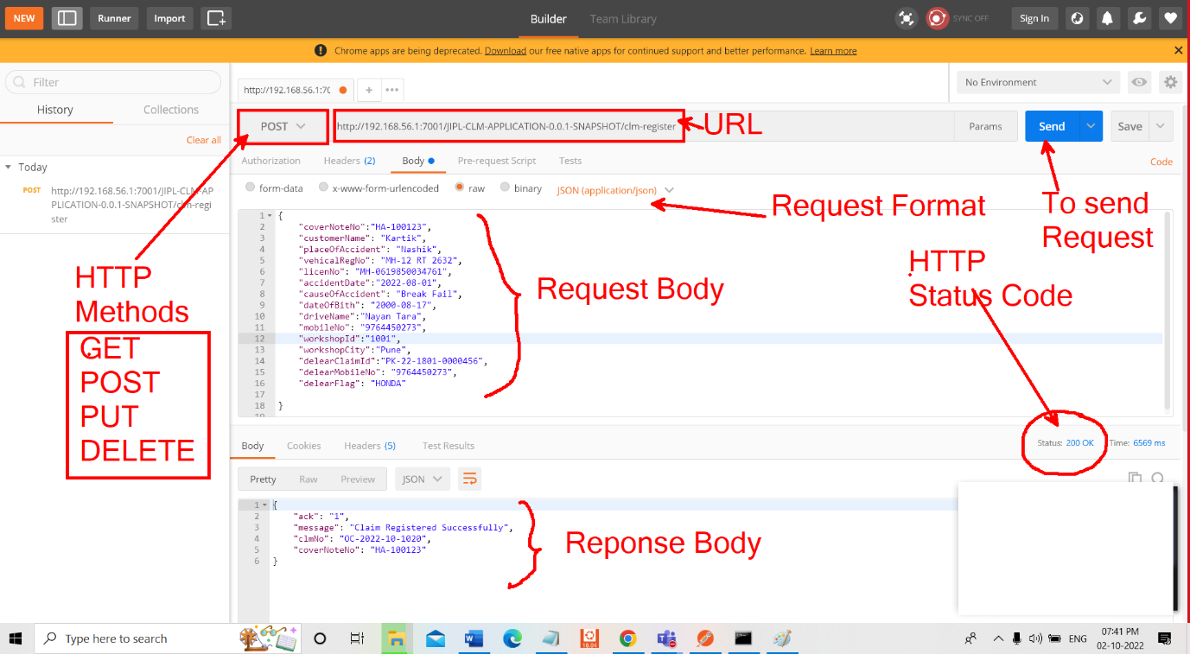

**When to use which HTTP Method**

1. GET – If we want to get data then we will use GET method
2. POST – If we want to insert data into database
3. PUT -> If we want to update database
4. DELETE-> To delete data from database

**HTTP Status Code**

When we send request to server then server process the request and send repose along with status code

200 -> Success

201 -> Created

400 bad request – Data is not in valid form

404 -> Page not found

403 -> Forbidden error

415 Unsupported Media Type = There is mismatch the request data format and server excepting data format

For Example If server is excepting JSON type data and you are sending request in XML format or other format then from server we will get status code as 415

500 -> Internal server

**Q. On which type of Application have you handled?**

Ans: I have handle java based Application

We have RESTful webservice and To Test RESTful webservice we use

Postman Tool

**Q. Which tool is used to connect Oracle Database?**

Ans: to connect Oracle Database we are using Toad Tool.

**Q. Which version of Oracle data base you are using?**

Ans: 12 G

**Q. Which middle ware you are using for your application?**

Ans: WebLogic

**Q. Which version of WebLogic you are using?**

Ans: 12 c

**Q. What is default port of oracle database?**

Ans: 8080

**Q. What is default port of WebLogic?**

Ans: 7001

Q. How to start and how to stop an application running on server?